- June SCHEDULE 2020  - Monday  - 10:00 – 11:15 Flow fusion  - 5:45 – 6:45 Yoga shred™ Vinyasa  - 7:00 – 8:15 cORE & rESTORE  tuesday  Note: Class sizes will be limited until otherwise notified. Preregistration is required for all classes.  Please respect social distancing and practice health & safety precautions.  - The Yoga House Team  - 9:00 – 10:15 gentle  - 10:30 – 11:30 Super stretch  - 4:00 – 5:15 hAPPY hIPS & bACK  - 5:30 – 6:30 vinyasa ii  - 7:00 – 8:15 warm flow fusion  - wednesday  - 9:00 – 10:15 slow flow  - 10:30 – 11:45 deep stretch – yin yoga  - 5:45 – 7:00 Restorative & yin blend  - 7:15 – 8:30 candlelit relief & restorative  - thursday  - 9:00 – 10:15 hAPPY HIPS & BACK  - 10:30 – 11:45 gentle  - 5:30 – 6:45 gentle  - 7:00 – 8:15 Weightless yoga (yoga trapeze) *limit 5  - friday  - 9:30 – 10:45 TGIF Yoga  - 11:00 – 12:15 MORE CORE  - 12:30 – 1:45 gentle  - 5:00 – 6:15 Prenatal yoga temporarily SUSPENDED  - 6:30 – 7:30 yogajuana  - saturday  - 8:30 – 9:30 HOT YOGA  - 10:00 – 11:00 deep stretch – yin yoga  - 11:15 – 12:45 stretch & strength for every body & mind  - sunday  - 10:00 – 11:15 WARM FLOW FUSION  - 12:00 – 1:15 deep stretch – yin yoga  - 6:00 – 7:15 candlelit relief & resorative | SPECIAL CLASSES  Wild Women Circle - New Moon in Cancer - Rise in Love with Holly  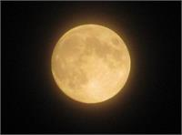  When: Saturday, July18th  Time: 2:00 - 5:00 pm  Cost: $40 early bird; or $45 within the week of circle.  *Food provided  Lakeside Yoga with Kim  When: Sunday, July 12th  Time: 8:30 – 9:30 am  Sound Bath Meditation with Diane  When: Sunday, July 19th  Time: 5:00 – 6:00 pm  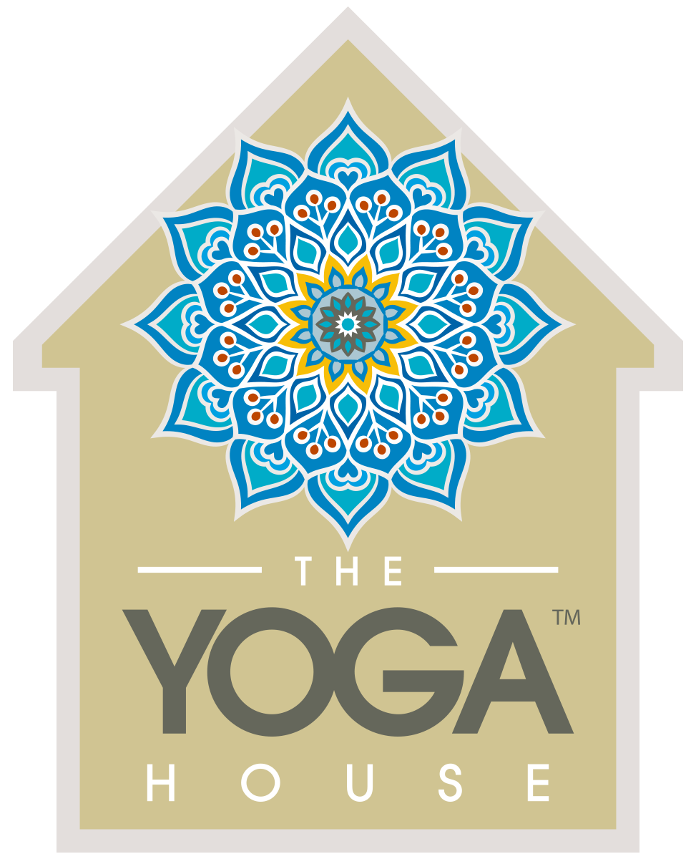  “Yoga for Everybody”

